**Pimpri Chinchwad Education Trust’s**

**PIMPRI CHINCHWAD COLLEGE OF ENGINEERING NIGDI, PUNE-44 DEPARTMENT OF INFORMATION TECHNOLOGY**



**Name of Course: AWT**

**Year & Branch: T.Y. B. Tech. (IT)**, **2022-23, Semester-II**

**AWT MINI PROJECT**

**ON**

**“ECOMMERCE DASHBOARD”**

**BY**

|  |  |
| --- | --- |
| **Roll No.** | **Name of Students PRN No.** |
| TYITA31 | Vedant Dhote 120B1F031 |

**GUIDED BY**

**Mrs. Tanuja Patankar**

**Abstract**

In today's fast-paced world, many people don't have the time or resources to visit multiple physical stores to find the products they need. An e-commerce website provides a centralized platform where customers can easily search for and purchase products from the comfort of their own homes. Our e-commerce website project aims to provide a convenient and efficient platform for customers to browse and purchase products online. We will be using React.js, a popular JavaScript library for building user interfaces, to create a fast and responsive shopping experience. It will eliminate the inconvenience of traveling to multiple locations to find products, while also making online shopping less overwhelming and confusing. Our website will offer a centralized platform where customers can find products from multiple sellers, compare prices and reviews, and shop with confidence. To achieve this, we will be creating a user-friendly interface that makes it easy for customers to navigate through the products, and we will ensure the site is secure and reliable. Our ultimate goal is to provide a seamless and enjoyable online shopping experience that meets the needs of modern consumers.

**Contents**

|  |  |
| --- | --- |
| 1 | Introduction |
| 2 | Motivation |
| 3 | Problem statement |
| 4 | Objective |
| 5 | Implementation |
| 6 | Methodology |
| 7 | Results and Analysis |
| 8 | Conclusion |

\

**1. Introduction**

In today's digital age, e-commerce has become an essential part of our daily lives. Online shopping offers convenience, accessibility, and a wide range of products at our fingertips. With the growing demand for online shopping, businesses are increasingly looking to establish their online presence to reach a wider audience. In this project, we aim to create an e-commerce website using React.js, a popular and powerful JavaScript library for building user interfaces. Our website will be designed to provide users with a seamless shopping experience, from browsing products to completing purchases. We will incorporate features such as product listings, search functionality, billing, adding products, shopping carts.

By the end of this project, we hope to have created an efficient and user-friendly e-commerce website that meets the needs of both customers and businesses. We will also have gained valuable experience in working with React.js and integrating with backend Firebase, which can be applied to future web development projects.

**2.Motivation**

One potential motivation for embarking on an eCommerce project with basic functionalities is market demand. If there is a significant demand for a particular product or service in the market, starting with basic functionalities can allow you to quickly establish an online presence and capture a share of the demand. Basic functionalities such as product listings, shopping cart, and searching functionality can provide a solid foundation for launching an online store and generating sales.Another motivation is cost-effectiveness. Developing an eCommerce platform with basic functionalities is typically more affordable compared to building a complex, feature-rich platform. Basic functionalities require less time, effort, and resources to develop, making it a viable option for businesses with limited budgets or those looking to test the market before investing in more advanced features. Basic functionalities provide a solid foundation for future scalability. You can gradually add more features and functionalities as your business grows and evolves, allowing you to adapt to changing customer needs and market demands.

**3.Problem Statement**

The problem that we aim to solve with this e-commerce website is to provide customers with a convenient and efficient way to browse and purchase products online. In traditional brick-and-mortar stores, customers may have to travel to multiple locations to find the products they need. Online shopping eliminates this inconvenience, but it can also be overwhelming and confusing to navigate through a large number of products and sellers.

**4.Objective**

The key objectives for this project may include:

● To generate sales through the eCommerce platform by providing an easy-to-use interface for customers to browse, select, and purchase products or services. The platform should be designed to facilitate smooth and secure online transactions, ensuring a positive shopping experience for customers.

● To penetrate the target market by addressing the demand for the products or services offered. Basic functionalities such as product listings, shopping cart, and searching and updating products should be implemented to enable customers to easily find and purchase products or services.

● To achieve a cost-effective approach by focusing on essential functionalities and avoiding unnecessary complexities. This may involve leveraging existing tools or platforms, utilizing cost-effective technologies, and optimizing development and operational costs.

● To have a quick time-to-market by developing and launching the eCommerce platform efficiently and expeditiously. This involves prioritizing essential functionalities, leveraging existing resources, and streamlining development and testing processes.

● To lay the foundation for future scalability. The platform should be designed with a modular and extensible architecture to easily accommodate additional features and functionalities as the business grows and evolves.

● To provide a positive and seamless user experience for customers, focusing on simplicity, ease of use, and intuitive navigation. The platform should be designed with a responsive and mobile-friendly layout, ensuring accessibility across different devices and screens.

**5.Implementation**

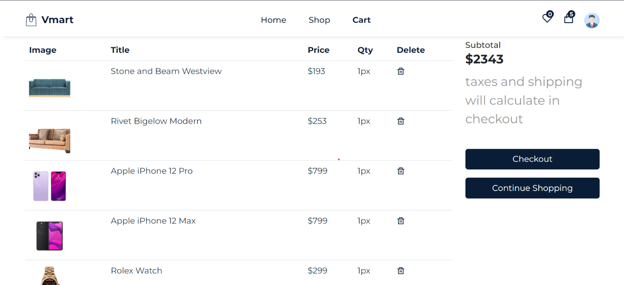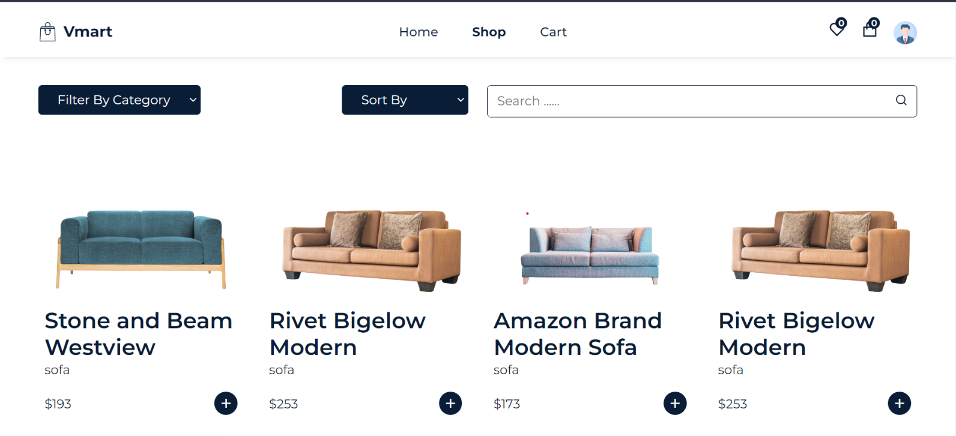

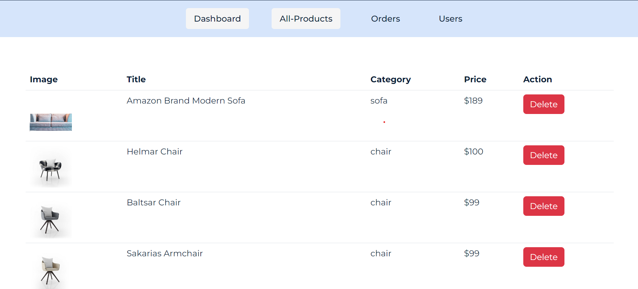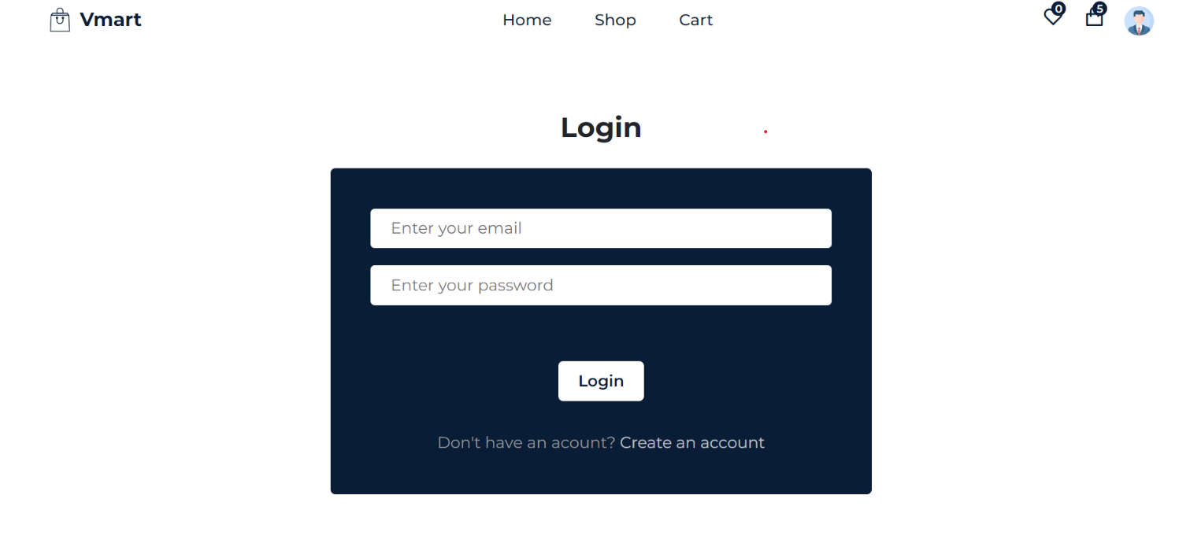**6.METHODOLOGY**

**Backend Development:**

● Set up the backend using Firebase storage.

● Create a RESTful API to handle CRUD (Create, Read, Update, Delete) operations for products and users.

● Implement user authentication and authorization using techniques such as JWT (JSON Web Tokens) for secure login and signup functionality.

● Implement password hashing using bcrypt to securely store user passwords. **Frontend Development:**

● Set up the frontend using React, a popular JavaScript library for building user interfaces. ● Create components for different UI elements such as login/signup forms, product list, product details, product creation/editing forms, etc.

● Implement user interfaces and views for various functionalities such as product listing, product details, add product, update product, delete product, etc.

● Implement user authentication and authorization on the frontend by making API requests to the backend for login, signup, and other user-related functionalities.

● Implement search functionality to allow users to search for products based on criteria such as product name, price, description etc.

**Integration and Testing**:

● Connect the frontend and backend by making API requests from the frontend to the backend for performing CRUD operations on products and users.

● Test the application thoroughly to ensure that all functionalities are working as expected. ● Debug and fix any issues or bugs identified during testing.

**Deployment:**

● Deployed the application on vercel platform.

**Enhancements:**

Implement additional features and functionalities based on the requirements of the e-commerce website, such as order management, payment gateway integration, user profile management, etc.

Continuously monitor and maintain the application, including regular updates and security patches to keep it secure and up-to-date.

.

**7.Result**

The e-commerce dashboard website Vmart developed using Reactjs and Firebase would include features such as user authentication, product management, search functionality, responsive design, and database integration. Users would be able to create accounts, log in, and log out securely, with

only authenticated users gaining access to certain parts of the website. Authenticated users would also be able to add and update products, as well as search for products based on keywords or filters, such as category, price range, or brand. The website would be designed to be responsive, ensuring accessibility and usability across different devices, including desktops, tablets, and mobile phones. Firebase storage would be used as the database to store and manage product data due to its compatibility with Node.js and ability to handle large amounts of data.

**8.Conclusion**

Our e-commerce website **Vmart** project aims to provide a convenient and efficient platform for customers to browse and purchase products online. By using React.js, we can create a fast and responsive user interface that provides a seamless shopping experience. Our website will offer a centralized platform where customers can find products from multiple sellers, compare prices and reviews, and shop with confidence. This project is important because it provides a solution to the inconvenience of traditional shopping methods, while also helping small and medium-sized businesses reach a wider audience. By leveraging modern technology to improve the shopping experience, we can build trust and loyalty with customers and promote entrepreneurship. Overall, our e-commerce website project has the potential to make a positive impact on both customers and sellers, and we are excited to bring it to life. We look forward to creating a platform that meets the needs of modern consumers and demonstrates the power of technology to improve the way we shop.